FISHERIES STOCK ASSESSMENT CAPACITY BUILDING: Training modules (and curriculum), plan and materials
- INTRODUCTION
The training needs assessment indicated that most trainees from Somalia hold advanced degrees in fisheries-related fields, with their understanding of fish stock assessment ranging from basic to intermediate levels. Participants strongly emphasized the need for practical, application-oriented training, specifically highlighting the critical role of robust data collection methodologies and comprehensive data analysis, both reinforced through hands-on exercises. They were also requested to bring their own datasets to the training to make the sessions more relevant, interactive, and directly applicable to their work. The training will be delivered using a combination of lectures, practical computer-based exercises, group work and discussions, as well as field-based activities at landing sites and during a ship-based survey.
By the end of the training, participants are expected to have a solid grounding in fish stock assessment, enabling them to explain the principles of population dynamics and stock assessment, identify appropriate sampling designs and survey types for fishery data collection, and describe key biological and ecological concepts. They will gain a clear understanding of different fisheries data types and develop practical skills in collecting length, weight, and gonad data using standardized methods, analyzing data with suitable statistical and modeling tools, and critically evaluating the uncertainty and limitations of assessment outputs. Ultimately, they will be able to apply this knowledge and these skills to prepare and present complete stock assessment reports for selected species upon returning to Somalia.

- TRAINING MODULES
The fish stock assessment training is structured into five distinct modules:
  - Module 1: Background and fundamental concepts in fish stock assessment
This module will teach participants why fish stock assessment is essential for successful, sustainable fisheries management. Participants will gain the foundational understanding required to perform these vital assessments. The module covers the following:

2.1.1 Introductions to fish stock assessment
- What is sustainable fisheries management?
- What is fish stock assessment, and why is it crucial for sustainable fisheries management?
- Why is fish stock assessment in important in sustainable fisheries?
- Which fisheries to focus on stock assessment?
- How assessment results inform policy, regulations, and conservation efforts.
- What are key requirements (challenges and limitations) to undertake fish stock assessment? Acknowledging the inherent uncertainties and complexities in assessing wild fish populations.
- Ecosystem-Based Fisheries Management (EBFM), an approach to managing fisheries that goes beyond catch data for a single species by considering the entire ecosystem:
- Integrating ecological, social, and economic considerations into fisheries assessment and management.
- Linking stock assessment results to ecosystem management

2.1.2 Basic fisheries biology and ecology of interest in fisheries management

- Fish life cycles: Key stages (egg, larva, juvenile, adult) and their relevance to population dynamics.
- Population dynamics: Core concepts of birth rates (recruitment), growth, natural mortality, and fishing mortality.
- Habitat and environment: Influence of environmental factors (e.g, temperature, dissolved oxygen, food availability etc.) on fish populations.

2.1.3 Key concepts in population dynamics
- Recruitment: Factors affecting the number of new fish entering the exploitable stock.
- Growth: How fish size and weight change over time, and common growth models.
- Mortality:
- Natural Mortality (M): Death from predation, disease, old age, etc.
- Fishing Mortality (F): Death due to fishing activity.
- Total Mortality (Z): The sum of natural and fishing mortality.
- Biomass: Total weight of a fish stock.
- Spawning stock biomass (SSB): Biomass of mature fish capable of reproduction
- Biological and exploitation reference points

2.1.4 Basic principles of exploitation
- Yield per recruit: Understanding how fishing pressure affects the catch from a cohort.
- Stock-recruitment relationships: How spawning stock size influences future recruitment
- Maximum sustainable yield (MSY): The theoretical maximum catch that can be taken from a fish stock indefinitely without impairing its ability to replenish.
- Overfishing:
  - Growth overfishing: Catching fish before they have had a chance to grow to their optimal size.
  - Recruitment overfishing: Reducing the spawning stock to a level where it cannot produce enough recruits to sustain itself.

The entire module is scheduled for Day 1 of the training. It comprises four distinct lectures, with each session allocated approximately 1.5 hours to cover content, group discussions, and dedicated question-and-answer periods.

  - Module 2: Data requirements for fish stock assessment
This module aims to provide trainees with a strong understanding of the data types, collection methods, and critical importance of data quality necessary for accurate fish stock assessment.
    - Types of Data
2.2.1.1 Catch and Effort Data
- Catch data—length and weight of individual fish— collected at landings sites (fisheries dependent data or fisheries independent data (ship-based surveys). This will include a practical session demonstrating data input using TAFIRI's Fisheries and Aquaculture Information Management System (FAIMS), digital data collection protocol. Can be downloaded at: https://play.google.com/store/apps/details?id=com.ecas.smartcas.
- Effort data-A measure of the time and power expended to catch the fish (e.g., number of fishing hours, number of hooks used, or standardized effort like hours towed by a specific vessel class). This will include a practical session demonstrating data input using TAFIRI's FAIMS (Fisheries and Aquaculture Information Management System).
2.2.1.2 Biological Data
This information helps understand the life history of the fish stock, which is essential for modeling population dynamics.
- Length: Samples are taken from the catch to determine the distribution of fish sizes, ages and maturity stage in each population. This is important for understanding how fishing pressure affects different age/size groups.
- Fecundity: The number of eggs produced. This is vital for estimating spawning stock biomass (SSB).
2.2.1.2 Environmental Data
- Data on temperature
- Salinity
- Food availability
- oxygen levels
- All above can influence stock distribution, recruitment, and survival.

    - Sampling Design and Data Collection Methods
2.2.2. 1 Sampling design
Sampling design is the systematic plan that dictates how, when, and where data will be collected. It is a fundamental step in any data collection effort, whether gathering fisheries data at landing sites or conducting resource surveys at sea. Participants will be introduced to Tanzania's data collection protocols for frame surveys.
- Why Sampling design is essential
We cannot realistically measure every single fish in a stock (the population). Therefore, we rely on taking a sample—a small, manageable subset—to represent the characteristics of the entire population.
- Importance of sampling design in fish stock assessments
The quality of the sampling design directly impacts the reliability of the assessment outputs. Its importance lies in:
- Reducing Bias: A proper design ensures that all parts of the population (e.g., small fish, large fish, fish from different areas) have a known, non-zero chance of being included in the sample. This is the foundation of scientific inference.
- Quantifying Uncertainty (Precision): It allows assessors to calculate the confidence intervals or margin of error around the stock estimates. This measure of precision is vital for communicating risk to managers.
- Cost-Effectiveness: A robust design identifies the minimum necessary sample size and collection effort needed to achieve the required precision, preventing wasted resources on unnecessary sampling.
- Temporal and Spatial Consistency: It ensures that data collected today is comparable to data collected last year, which is essential for tracking long-term trends in the stock.

- Key considerations in sampling design
Developing a successful sampling design requires careful consideration of several factors:
- Defining the Target Population: Clearly defining the fish stock (the population) being assessed, including its geographic range, time period of interest (seasons), and the specific life stage to be sampled.
- Defining the Sampling Unit: Determining the fundamental unit of collection (e.g., an individual fish, a single trawl tow, a boat trip, or a market basket).
- Choice of Sampling Method: Simple Random Sampling: Every unit has an equal chance of being selected (often impractical in fisheries). Stratified Random Sampling: Dividing the population into non-overlapping subgroups (strata) based on a known characteristic (e.g., depth, fishing gear, or region) and then sampling randomly within each stratum. This significantly improves precision. Systematic Sampling: Selecting units at fixed intervals (e.g., every 5th boat landing).
- Sample Size Determination: Calculating the required number of samples to achieve an acceptable level of precision. This often involves statistical formulas that consider the natural variability of the data.
- Unit of Measurement: If individual fish lengths are measured using a unit that is too coarse (e.g., measuring to the nearest centimeter when variability is low), the resulting data may exhibit poor resolution. This lack of detail can obscure the true population structure. In such circumstances, taking measurements to the nearest smaller unit (e.g., millimeters) is necessary to accurately capture the distribution and represent the population.
- Minimizing Non-Sampling Errors: Addressing potential errors not related to the sampling process, such as measurement errors (e.g., inaccurate scales) or recording mistakes (e.g., transposing numbers).
2.2.2. 2 Data collection
        - Catch data
These can be collected through both fishery-dependent sampling at landing sites and fishery-independent ship-based surveys.
  - At landing sites, enumerators record species, number of individuals, total weight, and individual length/weight measurements from local fishing vessels, utilizing standardized protocols for date, location, gear, and vessel type. Effort data, crucial for understanding fishing pressure, will be collected concurrently with catch data from landing sites. This includes metrics such as fishing hours, number of hooks/nets, and trip frequency, with a focus on standardization for CPUE calculation. A practical session will demonstrate at Kunduchi landing site using a digital data collection too— TAFIRI’s FAIMS application, available on Google Play. Course participants are encouraged to download the application prior the training.
  - For fishery-independent data, standardized scientific surveys (both trawl and longline) will be conducted in nearshore waters near Bagamoyo for three consecutive days, where participants will be trained to record catch by species and weight, measure lengths, and log essential survey parameters like position and gear configuration.

        - Biological data
- Biological data collection can be done in both landing-site and ship-based sampling to inform population dynamics.
  - Length data, vital for understanding how fishing affects different age/size groups, involve systematic measurements from representative catch samples, employing random or systematic sub-sampling and length-frequency recording.
  - Training will cover proper use of measuring equipment, digital data entry, and quality control.
  - Where feasible, age structures will be inferred from length data or direct aging methods, and maturity stages can be assessed through visual gonad examination for a subset of fish to support spawning stock biomass.
  - For key species, fecundity (number of eggs produced) is estimated through the collection of mature females and subsequent laboratory analysis, with standardized protocols ensuring data utility for recruitment analyses. Sex and stomach content will also be examined from the sampled fish species.
        - Environmental data
- Environmental data collection will focus on variables influencing stock distribution, recruitment, and survival.
  - In situ measurements, such as temperature, salinity, dissolved oxygen, and depth, will be recorded during ship-based surveys and at landing sites using CTD casts or handheld sensors. Additional observations like water clarity may also be noted.
  - Complementary to field measurements, secondary data from satellite and model-based sources (e.g., sea surface temperature, chlorophyll-a) will be accessed from online repositories.
  - Training will introduce participants to locating, downloading, and basic integration of these environmental datasets with catch and effort information, for example, by linking data based on date and location.
The entire module is scheduled for Day 2 of the training, comprising four distinct lectures. Each session is allocated approximately 1.5 hours, allowing ample time for content delivery, interactive group discussions, dedicated question-and-answer periods, and practical demonstrations using TAFIRI's existing digital fisheries data collection tool.

  - Module 3. Data Management—Data storage, Data entry and Processing
- This module will be predominantly practical, combining hands-on exercises with group discussions.
- Participants will undertake data entry trials using TAFIRI's Fisheries and Aquaculture Information Management System (FAIMS), a digital data collection tool available at: https://play.google.com/store/apps/details?id=com.ecas.smartcas.
- Given that participants are expected to bring their own datasets from Somali fisheries, course facilitators will provide guidance on data arrangement and cleaning. This is a time-intensive process, with the pace depending on each trainee's skill level and familiarity with data management.
- All participants are advised to bring their own laptops; those without computers will be grouped to share available devices.
The entire module is scheduled for days 3 and 4 of the training and will consist largely of practical sessions, focused on using TAFIRI’s digital fisheries data collection tool and processing the fisheries datasets that participants have brought specifically for the training.
  - Module 4. Data analysis, interpretation and reporting
Course participants will be introduced to stock-assessment techniques designed for data-poor fisheries—the reality for most Somali stocks. Working with their own length-frequency datasets, trainees will learn to: 1) analyse length distributions to separate juvenile and adult cohorts, 2) fit logistic curves to build maturity ogives, and 3) derive key biological and exploitation reference points when data allow. They will then apply the length-based spawning potential ratio (LB-SPR) method to estimate spawning-potential ratios, fishing pressure indices, and yield- and biomass-related benchmarks (see Figure 1). The module concludes with guided interpretation of these outputs, followed by participants preparing simple stock assessment reports based on their individual analyses.
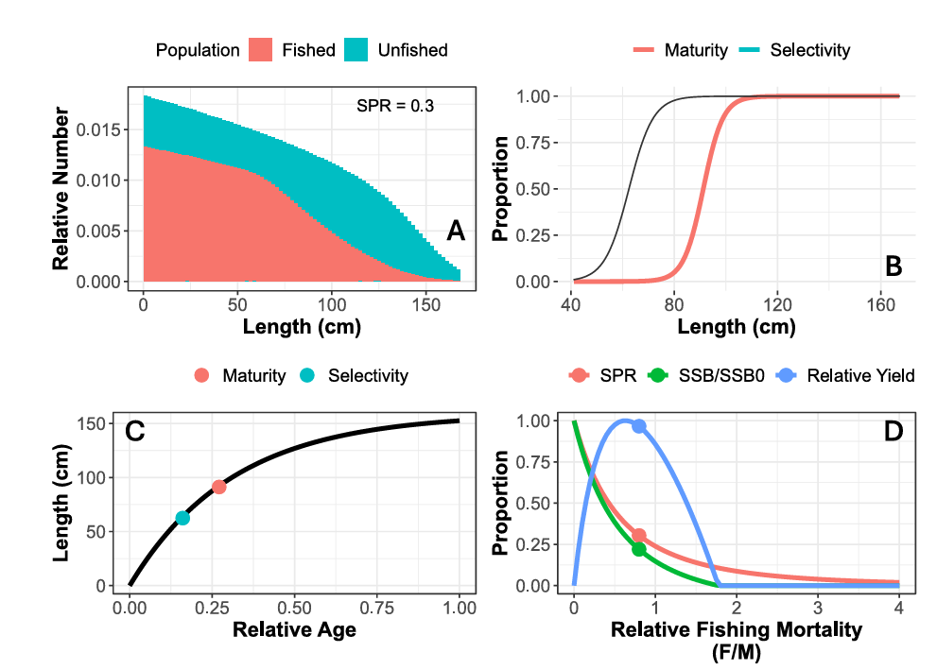
Figure 1. Example of outputs from LB-SPR model.
The entire module is scheduled for Days 5 and 6 of the training. These days will be largely dedicated to practical sessions, focusing on individual data analysis, generating figures, and interpreting the fisheries datasets that participants have brought specifically for the training.
  - Module 5. Field-based practical exercises
    - Data collection trials at Kunduchi landing site
- Course participants will engage in practical data collection, specifically gathering length-weight data at the Kunduchi landing site.
- This collected data will then be entered into FAIMS's digital data collection tool.
- Subsequently, at the training venue, participants will be instructed on how to retrieve this data for storage and further use.
- The course facilitators will make all necessary arrangements for this practical exercise, leveraging Kunduchi landing site's status as a regular monitoring location for TAFIRI's length-weight data.
This sub-module is scheduled for Day 7 of the training and will be largely dedicated to practical sessions focusing on data collection, entry, and retrieval from the FAIMS system available at TAFIRI. In the evening, participants will depart for Bagamoyo to board a vessel for ship-based survey.

    - Shib-based survey
- The ship-based survey will expose participants to two main fishing methods—trawling and longlining. For each haul or set, a subsample of the catch by species will be collected and examined to record key biological data, including length, weight, sex, maturity stage, and stomach contents.
- The resulting information will then be reviewed and discussed collectively to illustrate the types of insights these data provide for stock assessment and ecosystem understanding.
- Prior to boarding, trainees will receive essential briefings on survey procedures, safety, and sampling protocols, and, where necessary, will be assessed for medical and physical fitness to participate in the ship-based survey.
This module is scheduled for Days 8 to 10 of the training and will be largely devoted to practical, field-based sessions. During these days, participants will focus on fishing operations, species identification, and the collection of biological data.

- TRAINING PLAN
The training will span ten consecutive days, with six days dedicated to classroom-based instruction and four days to field-based activities, as detailed in Table 1. Each module will be covered for approximately 6 to 8 hours per day.
Table 1. Stock assessment training plan.
Module | Description | Delivery day
Module | Description | 1 | 2 | 3 | 4 | 5 | 6 | 7 | 8 | 9 | 10 | 11 | 12
1 | Background and fundamental concepts in fish stock assessment
2 | Data requirements for fish stock assessment
3 | Data Management—Data storage, Data entry and Processing
4 | Data analysis, interpretation and reporting
5 | Field-based practical exercises
5.1 | Data collection trials at Kunduchi landing site
5.2 | Shib-based survey
 | Graduation ceremony
 | Departure to Somali

- TRAINING MATERIALS
This comprehensive training will require the following materials to be used either in classroom-based instruction or field-based activities. These include:
- Personal computers
- Data collection protocols
- Fish identification guides
- Water parameter measuring equipment
- Tablets or personal smart phones to access Fisheries and Aquaculture Information Management System (FAIMS), a digital data collection tool available at: https://play.google.com/store/apps/details?id=com.ecas.smartcas.
- Pens
- Flip charts
- Notebooks
- Lab coats
- Presentations
- Guidelines for determination of fish gonadal stage and sex
- Projector
- Fish measuring boards, scales, sampling kits
- Data forms (printed + digital)
- Excel / R templates
- Safety PPE for vessel-based survey
- Internet access

